First thing we do to create a network using makeNetwork.m, the network we created with 2694 nodes and 94 clusters.

**Note:** The clustering algorithm I wrote will be in the file MCL.m and the network in the file HW2Net1.NET

Also, the clustering algorithm with different parameters in the files MCLe*r*.clu, Instead * will be listed the value of the parameters

**Note:** To check the Markov algorithm in file MCL.m and compile the code, you can change the two parameters R, E in lines 13-14, and the number of the node's and the cluster's in line 11-12

**Note:** The images are saved in order from the first to the end are counted by serial number for example: Pic1, Pic2, …, PicN

The first picture **Pic1:**

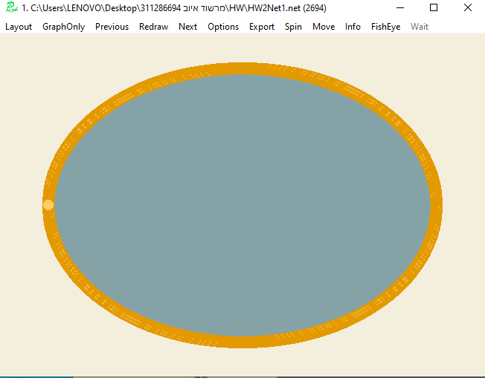

With some processing on the network **Pic2:**

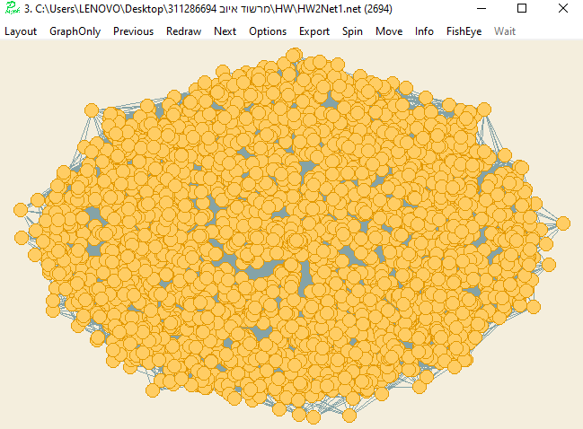

**Node:** this is the first part that include the probability of 0.6 if in the same other cluster 30/2694

The next picture produces the graph with the division we got Pic3

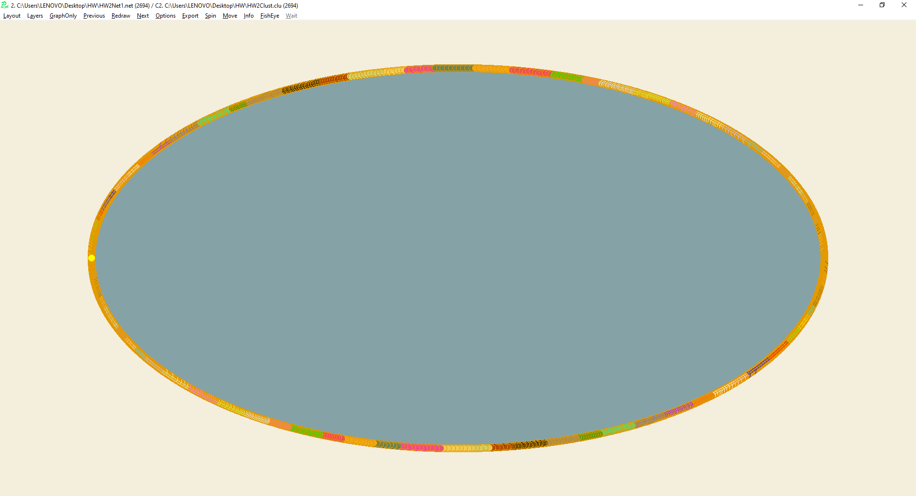

Pic4 :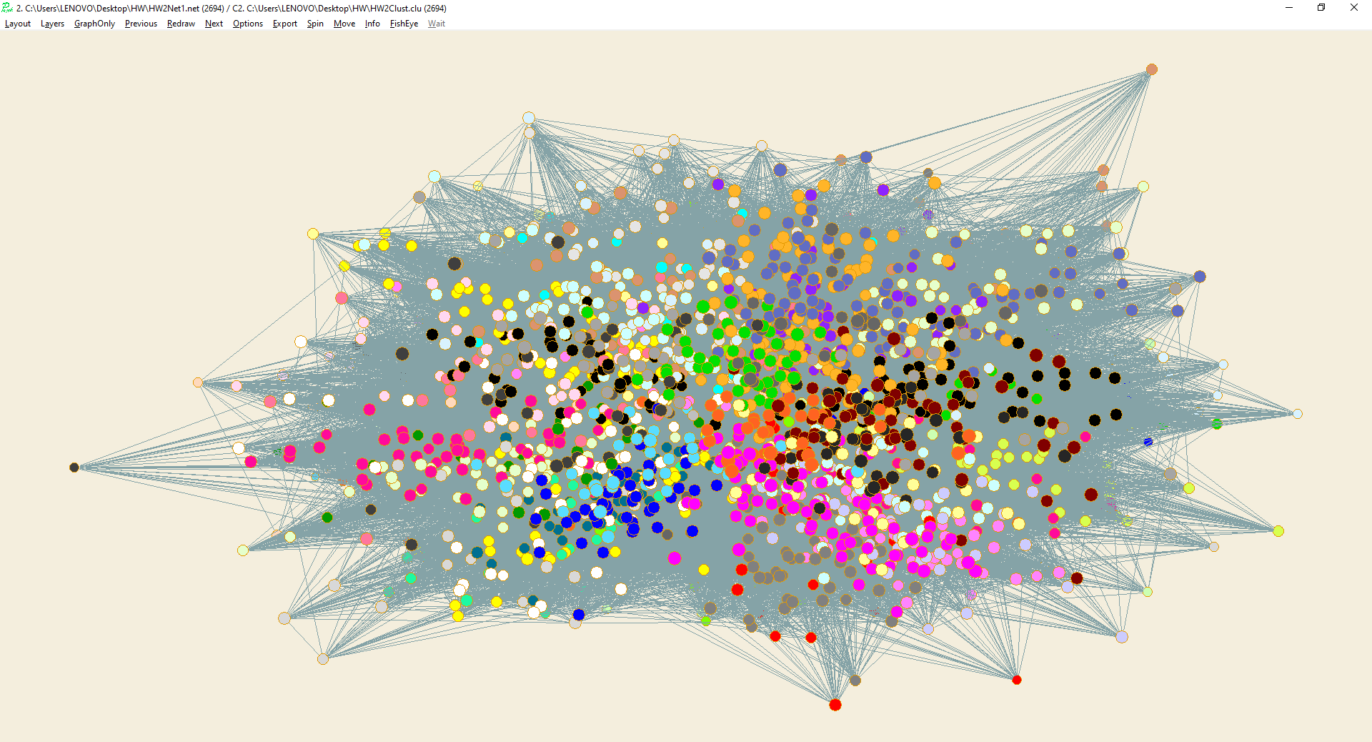

Now, after we run MCL Algorithm:

In the first step if we take the two parameters E and R which will be equal to 2

The result after this step in Pic5

Pic5:

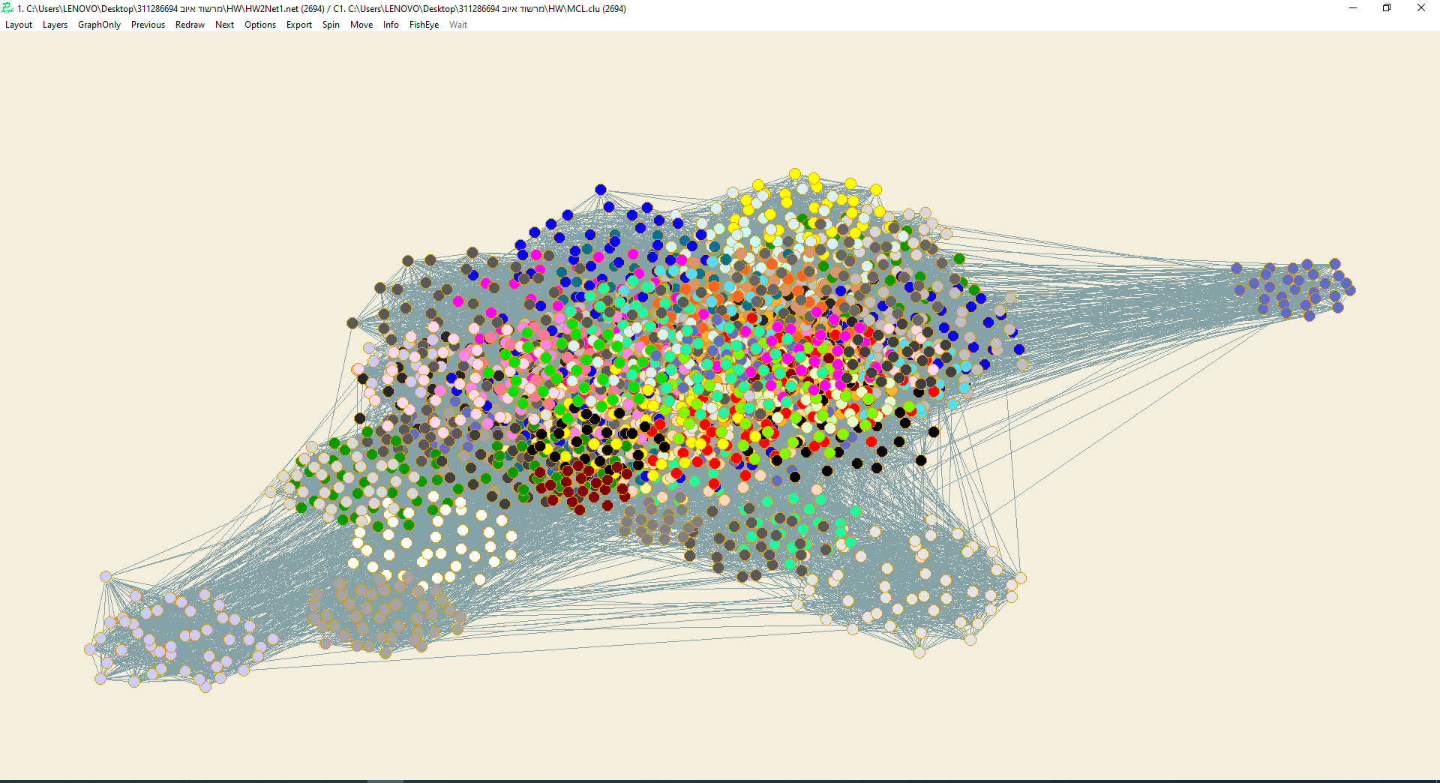

Pic 5.1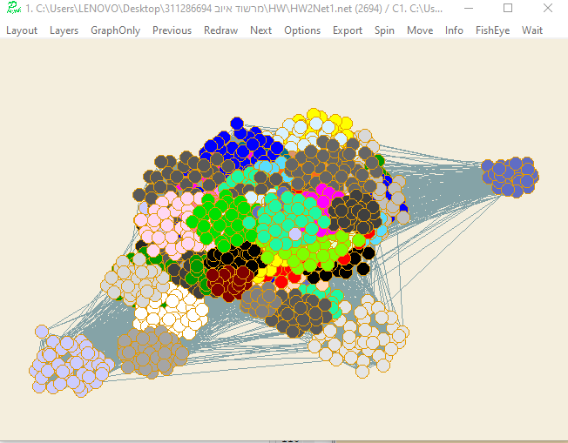

**Now** to check what the two parameters E and R affect the cluster; we try to change this parameter and we will examine what will be the new division of the graph

With parameters E=2, R=3

Pic 5.2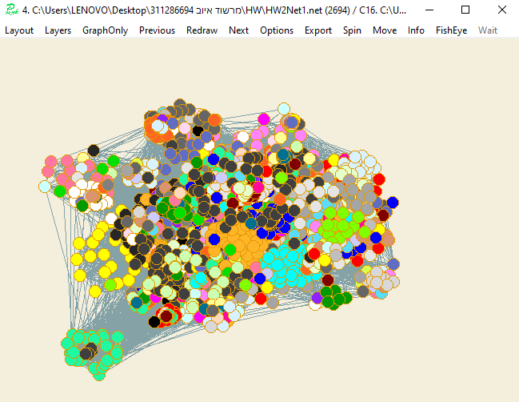

With parameters R=8, E=8 pic6

pic6

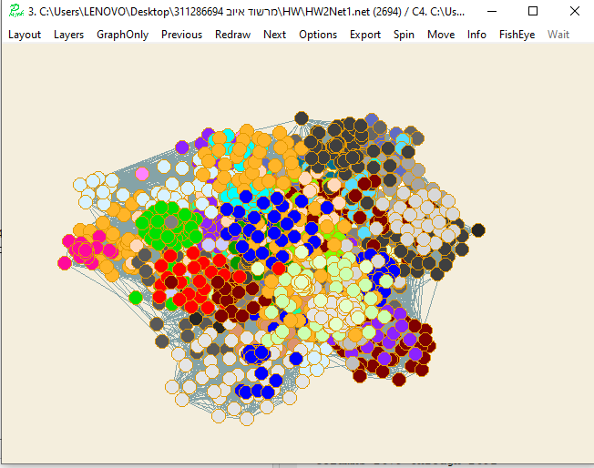

we can see if we increase them the number of clusters will be less than the previous step

Now with E=2, R=8 Pic7

Pic7:

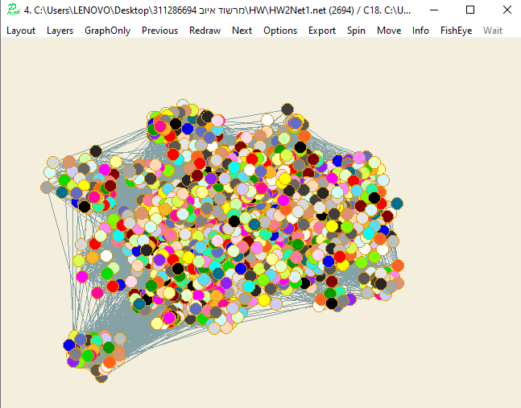

We can see the number of clusters increasing now from the previous time

Now with E=8, R=2 Pic8

Pic8:

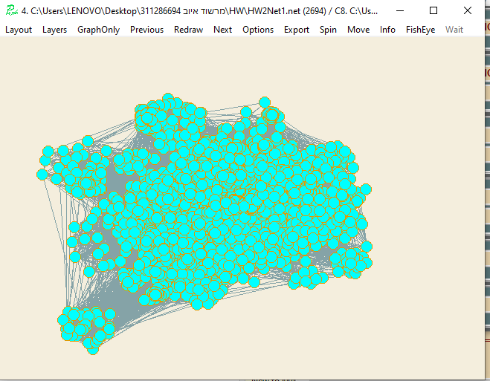

We can see that all the nodes are in the same cluster now, if we increase the E it reduces the number of clusters but if we increase the R it increases them provided the second parameter is constant

Now with E=2, R=16 Pic 16

Pic16

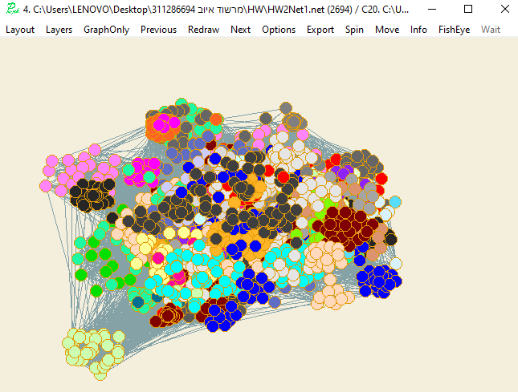

We took the same R and changed the E to be less than 8 (previous state) and equal to 5

It is possible that the number of clusters increases and each time you reduce it the number of clusters increases.

Now we’ll try to enlarge them together and change them

With E=5,R=3 Pic14

Pic14:

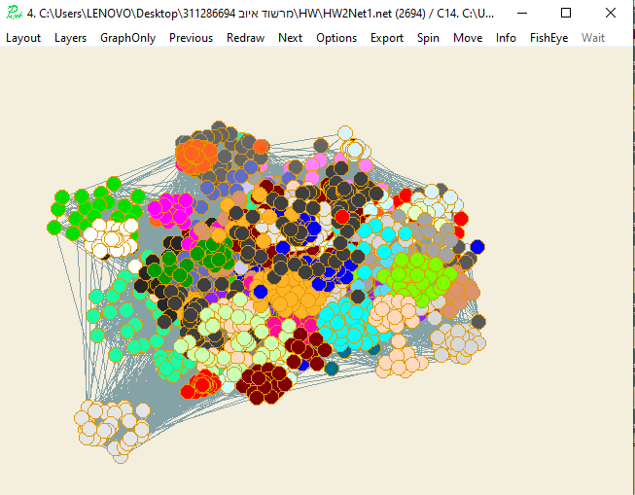

**Now with R=16, E=16 Pic9**

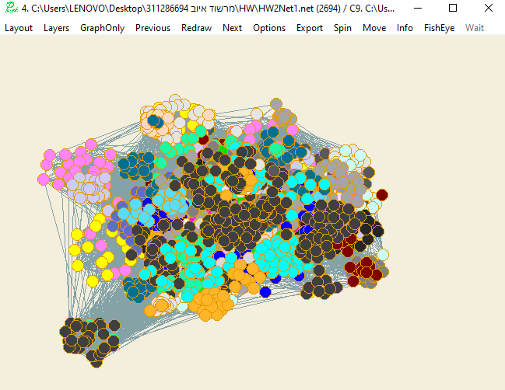

**We can see that this division is better than all the divisions so far**

**With E=20, R=20 Pic 10**

Pic10

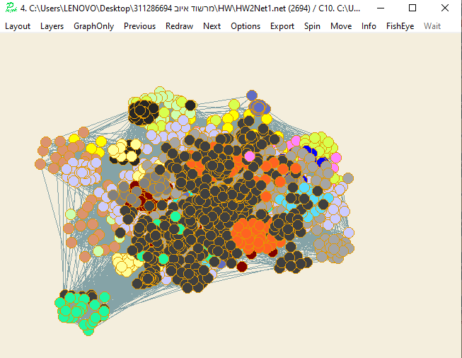

**We see that we have one large cluster and the rest are small and their number is less than all the previous situations this is the best choice I have had in my experiment**

**With R=20, E=2 Pic12**

Pic12

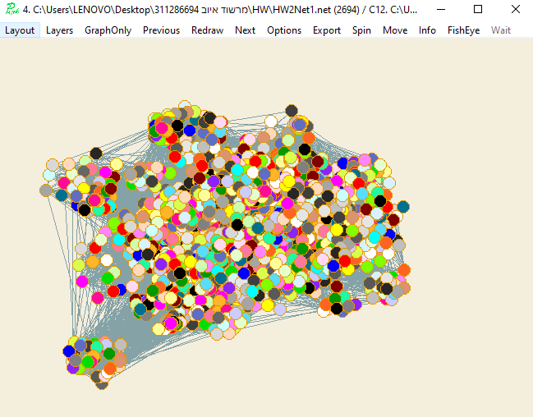

Here the number of clusters increases

Now With E=2, R=20 Pic13

Pic13:

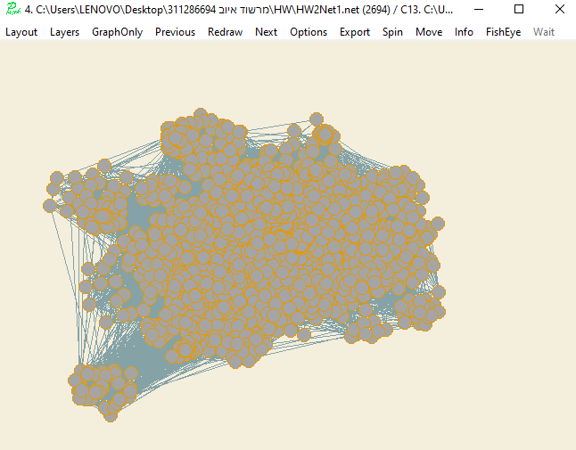

**If the R and E are equal to 32 PIC11**

**summary-** When we increase the two parameters the number of clusters we will have will be less than the existing state (except if in the existing state we are in one cluster).

And then if we increase one of the parameters for example a constant E and R we will also have a division with fewer clusters than what will be

But if we increase the second parameter R and E constantly we can see that the number of clusters increases now until we reach the final state

So the best choice I got when I set the parameters to be equal to 8 because we see that we have one large cluster and the rest are small and their number is less than all the previous situations it is the best choice I have in my experiment

**MARKOV code I implemented**

%

% @author Marshood Ayoub

% @version Oct 2019,

% @email:- marshood.ayoub@gmail.com

%

clear;

clc;

% make a network

clear;

clc;

N = 2694; % the amount of nodes is 2694

E=32;

R=32;

net = makeNetwork (N,94); % 94 clusters

a = net{2}; % a is a associated matrix

%M=[1,1,1,1

% 1,1,0,1

% 1,0,1,0

% 1,1,0,1]

%a=M;

for i=1:N % 3. Add self loops to each node

a(i,i)=1;

end

b=a; % B is a Normalize matrix

S = sum(a,1)

for i=1:N

for j=1:N

if(a(i,j)==1)

b(i,j)=1/S(j);

end

end

end

% now Expand by taking the eth power of the matrix

C=b;

%for i=1:E

%C = C*b;

%end

C = b^E;

%Inflate by taking inflation of the resulting matrix with parameter r

for i=1:N

for j=1:N

C(i,j)=power(C(i,j),R);

end

end

% now we want to normalize the new matrix

c1=C; % B is a Normalize matrix

oldmax=c1;

S = sum(c1,1)

for i=1:N

for j=1:N

if(C(i,j)~=0)

c1(i,j)=C(i,j)/S(j);

end

end

end

C=c1;

res=0;

while res ~= 1

% now Expand by taking the eth power of the matrix

C=c1;

%for i=1:E

%C = C*b;

%end

C = c1^E;

%Inflate by taking inflation of the resulting matrix with parameter r

for i=1:N

for j=1:N

C(i,j)=power(C(i,j),R);

end

end

% now we want to normalize the new matrix

c1=C; % B is a Normalize matrix

S = sum(c1,1);

for i=1:N

for j=1:N

if(C(i,j)~=0)

c1(i,j)=C(i,j)/S(j);

end

end

end

C=c1;

newmax=oldmax;

oldmax=c1;

tf = isequal(c1,newmax);

res=int8(tf);

end

cfid = fopen ('MCL.clu','w');

fprintf (cfid,'*Vertices %d\n',N);

clustIndexes(1,94) = N;

clustVect = zeros (1,N);

currIndex = 1;

for i=1:N

for j=1:N

if C(i,j)~=0

fprintf (cfid,'%d\n',currIndex);

end

end

currIndex = currIndex + 1;

end

fclose (cfid);